Application Workflow for VS4 Functionality

Steps | Description
1 | Log In with credentials
2 | Land on home page
3 | Click on Services on the vertical menu
4 | Click on Submit Report / Returns
5 | Click on Submit Report
6 | Click on Request Type
7 | Select Fit and Proper ( Depends on the scenario)
8 | Select1st Declaration
9 | Select 2nd declaration
10 | Click on Submit
11 | View submission Number with success message
12 | Land on home page automatically after 15 seconds
13 | Click on Services on the vertical menu
14 | Click on View submission
15 | Click on the dropdown on the right corner of the screen and select Reports & Return Dropdown
16 | Search for the submission number on the table and select
17 | Can have a detailed view of the submission done along with the status ssubmitted.

General Workflow:
- Login to OnefinSurv Application ( https://onefinsurv-qua.resbank.co.za)
- Click Services
Once clicked Services, you can see these options,
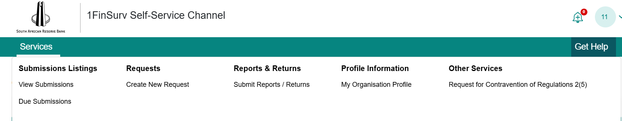
Depending on the user story, you need to click the respective option

